PAY & EQUALITY BALLOT
14 January – 22 February 2019
ESSEX

WHAT IS THE DISPUTE ABOUT? WHY VOTE TO STRIKE?
We want universities that are world-leading and genuinely meritocratic: institutions which are open to, and open opportunities for, students and staff from all walks of life. To fulfil this role, academia needs to remain a viable career path, both for current staff and for the next generation. At the moment, precarity, declining pay, and increasing workload are closing off avenues into academia and threatening the future of the sector. This dispute is about building the foundations of a fairer university—security of employment, fair pay, sustainable workload, and equality. These reinforce each other: for example there are structural causes for gender and race inequalities, and for unchecked workloads, which cannot be tackled without a fair national pay scale and greater employment security. Getting these foundations right is vital for today’s staff and students, but also for the future of UK Higher Education.
The 2018 national claim (agreed by UCU with the four other HE trade unions) seeks action on all four fronts: . .
A national framework to address  precarious contracts. | A pay increase of 7.5% or £1500  (whichever is greater).
Addressing excessive workloads. | A sectoral commitment to eliminate the  gender pay gap.
National action is needed on the pay scale, and to advance anti-casualisation and equality agendas. So far negotiations have not produced the progress needed. We recommend you vote YES to Industrial Action, YES to Action Short Of Strike, in support of the national claim. But whatever your view, the important thing is to vote.

WHY IS UCU BALLOTING FOR INDUSTRIAL ACTION AT A TIME OF SUCH UPHEAVAL?
The ballot seeks a mandate for industrial action before the next round of pay negotiations. It falls at a difficult moment, as universities are facing great uncertainty over fee income and Brexit. But the case for action is strong. We set out overleaf the arguments on each aspect of the claim. We believe it’s vital to take action now, despite prevailing uncertainty in the sector. Staff too are feeling the uncertainty; they have borne increasing burdens, and are themselves facing financial pressures. And securing the future of the sector requires action today. Key indicators—pay relative to inflation, increases in top-level staff salaries relative to those of university staff as a whole—have been headed in the wrong direction for years. If this continues, deteriorating conditions will cause profound damage. We have seen no plan from the universities to address this. Despite some local advances, there has been little movement on casualisation, and pay can only be addressed nationally. It is precisely because the sector is under pressure, and there seems no prospect of employers taking the initiative, that we need concerted action now.

WHAT INDUSTRIAL ACTION IS PLANNED?
If the ballot secures 50% support for action and clears 50% turnout—on an aggregate national basis—national negotiators will draw up plans for industrial action. We would expect serious strike action, but not as long as the USS strike. The earliest point for industrial action would fall towards the end of Spring Term. As always, the decision to vote to strike is a difficult one. Members will be concerned about the impact on students in particular. But the concerns reflected in the dispute affect the future of the whole sector, including the learning environment for students, and the career prospects of graduate students aspiring to academic careers. Strike action is a last resort to force action on these issues.

ACTION ON PRECARIOUS CONTRACTS AND CASUALISATION
Only 49% of HE staff hold open-ended contracts, meaning that a significant share of vital teaching and other professional work in HE is performed by staff on insecure contracts (fixed-term, or “atypical” – variable hours, hourly paid, zero hours, agency contracts). The precarity of many insecure contracts undermines the viability of careers in the sector, and amplifies inequalities (e.g. men hold 27% more open-ended contracts than women). Casualisation can also undermine the quality of teaching, and harm student learning.
A RETURN TO FAIR PAY
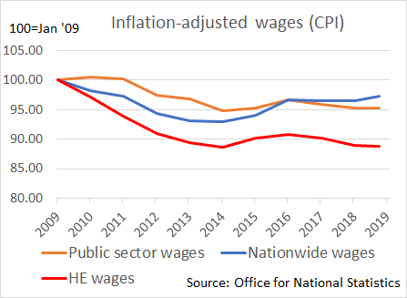
Real-terms pay in HE has declined significantly over the last decade. Since Jan 2009, real-terms pay has fallen by 11.4% (using CPI to measure inflation), and 17.6% (using RPI). Had pay kept pace with inflation, a staff member with median pay (£33,000) would today be earning between £3,800 (CPI) and £5,740 (RPI) more.
The 2018 pay offer, a 2% increase implemented in Sep 2018, was less than inflation, making it a real-terms pay cut, and continuing the decade-long slump in real-terms pay. The erosion of HE pay has been markedly worse than nationwide wages and worse than the public sector.
Constraints on pay are not felt equally. At Essex, the VC’s pay has risen 23.9% in real terms (using RPI) since 2013. A small minority of employees at Essex receive a ‘market pay supplement’.
The impact of the real-terms pay cut is exacerbated by threats to the USS defined-benefit pension. The current outlook on pensions is uncertain, with no consensus on the future of the scheme, and refusal by USS to accept compelling expert criticisms of its valuation approach. A shift from the defined-benefit pension as it existed in 2017 to the defined-contribution model last proposed by employers was estimated by UCU’s actuaries to entail a loss of approximately £200,000 in retirement benefits for a typical new employee. Losses imposed by whatever reforms are made in future remain to be calculated. Between pay and pension cuts, careers in HE in the UK are becoming less and less attractive, particularly for students graduating with significant debt.
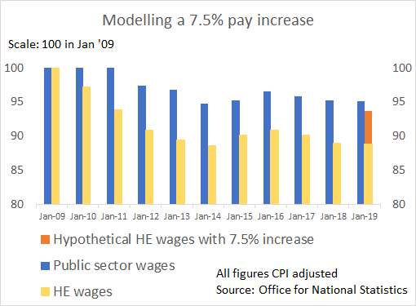
The 7.5% increase sought is modest. It recoups only some of the decline in real-terms pay and still leaves HE wage recovery short of that in the public sector.
This increase is affordable. Total staff costs have shrunk in recent years as a fraction of HE income, from 56.6% (2009–10) to 52.9% (2016–17). At Essex, staff costs were 54.4% of total expenditure in 2016-17, which the Finance Committee reported to Council is ‘a low staff to operational costs ratio’.
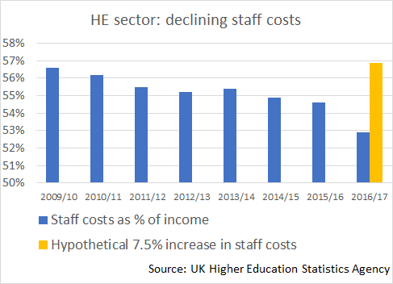
Although the relation between pay and total staff costs is complicated by e.g. pension contributions, a 7.5% increase in staff costs would bring them back to 2009–10 levels.
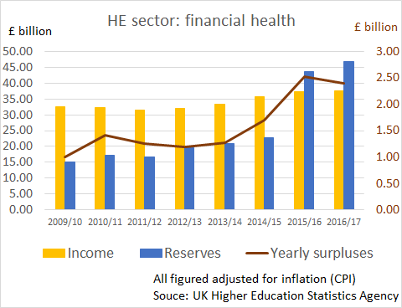
The last decade has seen massive growth in reserves across the sector, from £12.32 billion (2009–10) to £44.27 billion (2016–17). There is no doubt that funds are available. At Essex, reserves of £239,449,000 were held on 31 July 2018. In recent years the University has enjoyed real income growth matching or exceeding many successful private sector businesses, whilst limiting growth in key elements of its cost base (mainly wages). Essex University has been through a period of favourable financial circumstances for the institution, while most of its employees have experienced a fiscal squeeze.
Future conditions may be more challenging, and some other universities may be in a more difficult financial position than Essex. But this cannot be an excuse for failing to act on long-needed improvements to pay and conditions. What the sector cannot afford in the long term is to keep sacrificing staff pay and conditions. This will ultimately damage British higher education, by affecting the quality of teaching, calibre of research, and our ability to attract international students, staff and research funding.

ADDRESSING EXCESSIVE WORKLOADS
University staff work far more hours than we’re paid for. Workload is growing. Excessive workloads already take a toll on physical and mental health. In a 2018 THE survey, 38% of academics reported working over 5 hours at weekends; 65% of academic-related staff said that their partner regarded the hours that they work as detrimental to a healthy family life. In a 2016 UCU national survey, 83% of academics reported the pace of work had increased over the past three years. Over 25% of all respondents stated that their workload was unmanageable.
UCU considers workload to be a health and safety concern. Workload also ties into other damaging trends—precarity, low pay, and inequality. Extra hours squeezed out of staff are often driven by fears about job security, with women and minorities more likely to do the time-consuming, poorly-rewarded "invisible” work. UCU Essex is addressing these intersections through work on anti-casualisation and equality. The national claim emphasises excessive workloads as a justification for the pay demand, and puts the issue on the agenda for coordinated action.
CLOSING THE GENDER PAY GAP AT ESSEX (Yes, we still have one even though THE seems to think we don’t!)
Across the sector, the gender pay gap stands at around 12%. At Essex the picture is worse. Despite the much-lauded one-off payment to female professors in 2016, which removed the gender pay gap for that small sector of our academic community, the picture across the campus in general is not so positive. As of March 2018, the median gender pay gap stood at 18.6% and the mean GPG at 17.6% (against the sector average of 12.2% and 12.0% respectively). Removing the gap in pay between male and female professors was relatively easy in comparison to the complexities fueling the continuing Gender Pay Gap at Essex. Essex UCU is committed to ensuring that the university does not lose sight of the need to tackle this form of inequality, however difficult and complicated eradication may be.

The national claim builds the foundations of a stronger, fairer university. We’re urging members to take action in defence of their own interests, but also for their colleagues, for students, and for the future of the sector. Talk with your colleagues about the ballot. And please – USE YOUR VOTE.

HESA data, 2016–17, https://www.hesa.ac.uk/news/18-01-2018/sfr248-higher-education-staff-statistics.
In the Essex 2012-13 accounts the VC’s remuneration package was published as £263,300. This grew to £378,100 in the 2017-18 accounts. (Using an online inflation calculator which concluded that the RPI effect equated to 15.9%)
http://www.ussjep.org.uk/files/2018/09/report-of-the-joint-expert-panel.pdf.
https://www.ucu.org.uk/media/8916/TPS--USS-no-DB-comparison-First-Actuarial-29-Nov-17/pdf/firstacturial_ussvtps_nodb_29nov17.pdf.
HESA Finance Plus 2016–17 dataset (March 2018).
Essex University, ‘Top Lines’, Issue 10, Friday 6 July 2018.
HESA Finance Plus 2016–17 dataset (March 2018).
Ellie Bothwell, ‘Work-Life Balance Survey 2018: Long Hours Take Their Toll on Academics’, THES, 8 Feb 2018 (https://www.timeshighereducation.com/features/work-life-balance-survey-2018-long-hours-take-their-toll-academics).
‘Workload is an Education Issue: UCU Workload Survey Report 2016’ (https://tinyurl.com/zjox6vh) 44.
https://digital.timeshighereducation.com/THEawardswinners2018/html5/index.html
From 2015–16 data: UCU, The Gender Pay Gap in Higher Education (https://tinyurl.com/ydy54rxf).
https://www1.essex.ac.uk/news/event.aspx?e_id=10552
University of Essex Gender Pay Gap Report 2018
https://www.ucu.org.uk/media/8619/The-gender-pay-gap-in-higher-education-201516---summary-May-17/pdf/ucu_2015-16genderpaygapreort_executivesummary_may17.pdf

